**CIRCUIT CONNECTIONS TO GPIO PINS OF ARDUINO NANO: -**

**MAX-485 TTL to RS-485 Converter Module Connections :-**

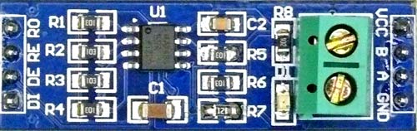

|  |  |
| --- | --- |
| **Arduino Nano** | **MAX-485 TTL to RS-485 Converter Module** |
| **0(RX)** | RO |
| **1(TX)** | DI |
| **2** | RE |
| **3** | DE |
| **+5V** | VCC |
| **GND** | GND |

**16x2 LCD Display Connections :-**

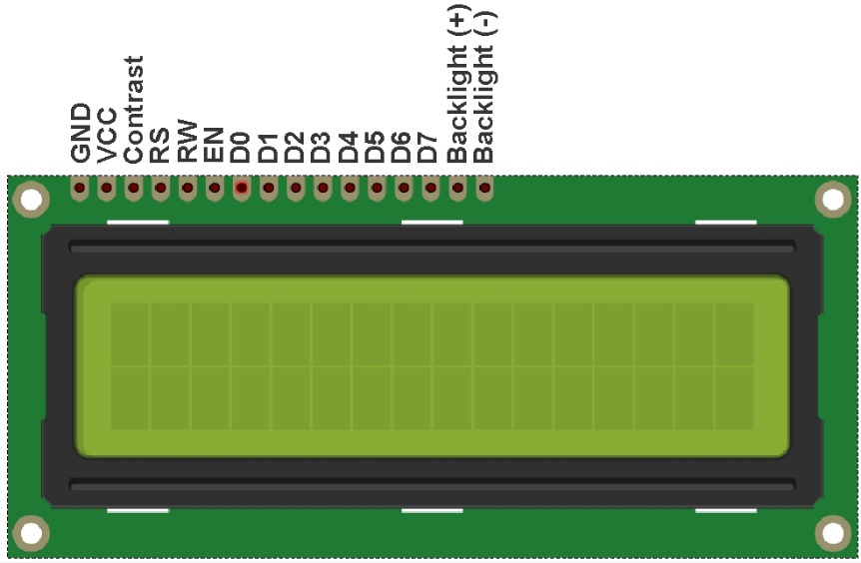

|  |  |
| --- | --- |
| **Arduino Nano** | **16x2 LCD Display Module** |
| **4** | D4 |
| **5** | D5 |
| **6** | D6 |
| **7** | D7 |
| **8** | RS |
| **9** | EN |

**SD Card Module Connections :-**

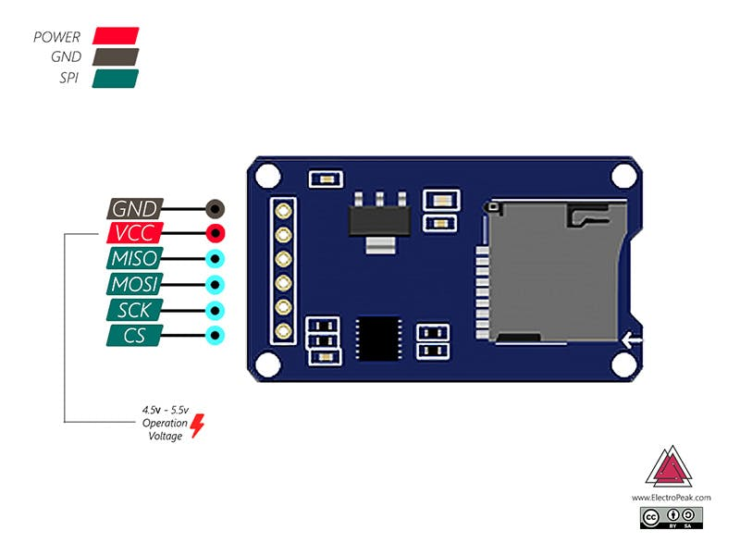

|  |  |
| --- | --- |
| **Arduino Nano** | **SD Card Module** |
| **10** | CS |
| **11** | MOSI |
| **12** | MISO |
| **13** | SCK |
| **+5V** | VCC |
| **GND** | GND |

**Red and Green LED Connections :-**

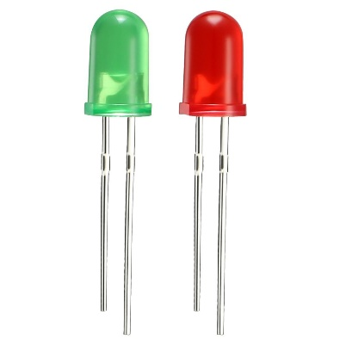

|  |  |
| --- | --- |
| **Arduino Nano** | **LED** |
| **A0** | Anode terminal of **Red LED** with **560 Ohm resistor** |
| **A1** | Anode terminal of **Green LED** with **560 Ohm resistor** |
| **GND** | Cathode terminal of Red and Green LED |

**Rotary Encoder Module Connections :-**

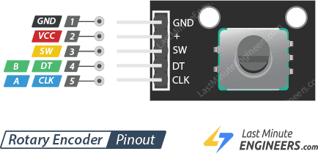

|  |  |
| --- | --- |
| **Arduino Nano** | **Rotary Encoder Module** |
| **A3** | CLK |
| **A4** | DT |
| **A5** | SW |
| **+5V** | VCC |
| **GND** | GND |

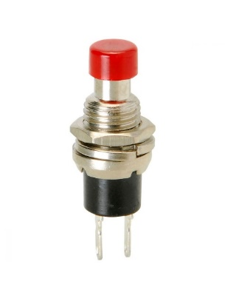**Push Button Connections :-**

|  |  |
| --- | --- |
| **Arduino Nano** | **Push Button** |
| **RST** | 1st Terminal |
| **GND** | 2nd Terminal |

**Push Button Connections :-**

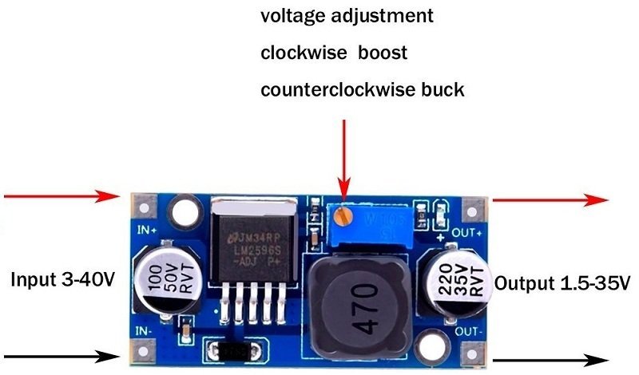

|  |  |
| --- | --- |
| **Arduino Nano** | **Push Button** |
| **Vin** | OUT + |
| **GND** | OUT - |

**Weight Transmitter Device Connections :-**

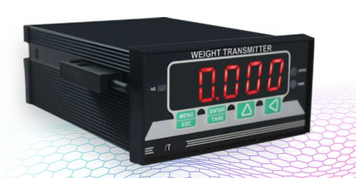

|  |  |
| --- | --- |
| **MAX-485 TTL to RS-485 Converter Module** | **Weight Transmitter Device** |
| **A** | A |
| **B** | B |

**CIRCUIT DIAGRAM:**

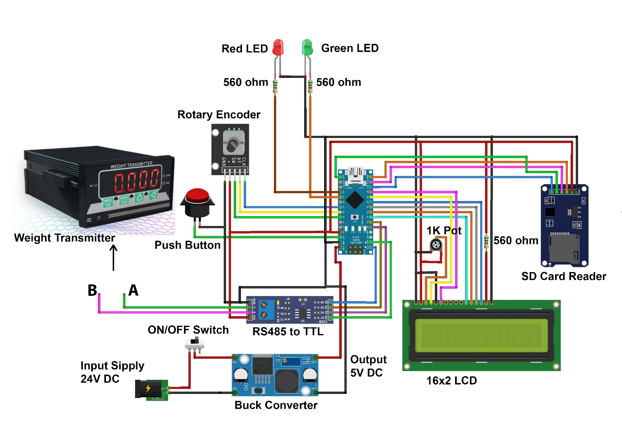

**BILL OF MATERIAL (BOM) :**

**REQUIREMENTS**:

1. Weight Transmitter
2. Load Cell
3. Arduino Nano
4. MAX-485 TTL to RS-485 Converter Module
5. 16x2 LCD Display Module
6. SD Card Module
7. 16 GB SD Card
8. Rotary Encoder Module
9. 2 x LED (RED & GREEN)
10. 3 x Resistors (560 ohm)
11. Push Button
12. ON/OFF Switch
13. LM2596 buck converter
14. Potentiometer
15. 24V Adapter

**BILL OF MATERIALS –**

|  |  |  |  |
| --- | --- | --- | --- |
| Sr. No. | Parts | Nos. | Estimated Cost |
|  | Arduino Nano | 1 | 399/- |
|  | Weight Transmitter | 1 |  |
|  | Load Cell | 1 |  |
|  | MAX-485 TTL to RS-485 Converter Module | 1 | 60/- |
|  | Red & Green LEDs | 2 | 5/-per piece |
|  | Resistors | 3 | 2/-per piece |
|  | 12V 1A Power supply adapter(comes with the meter) | 1 |  |
|  | 12V to 5V Buck converter | 1 | 60/- |
|  | Wires | 20 | 2/-per piece |
|  | 2 pin ON/OFF switch | 1 | 20/- |
|  | SD card -16GB | 1 | 400/- |
|  | SD Card Reader module | 1 | 90/- |
| Total Estimated Cost: | | | **xxx/-** |